**Practical No. 4**

**AIM:** "Eco base Printers" has been printing business cards for the last 20 years. The management wants to upgrade their system into a website to take orders online. The design templates with the design code, price per 100 cards, description and image of the template will be available for the user's choice. The user may select any of the template and name place order for the same. Before recording the order, customer’s information, such as name, mailing address, email, and phone number should be recorded. For the order, customers can choose more than one template, the design code, matter to be printed, quantity should be recorded for each of the designs. Also, a transaction record must be created for each order that records the payment details made by credit card. For the above case study, draw:

1. list the classes used

2. Use case diagram

3. Collaboration diagram (For any one-use case)

**SOLUTION:**

1. PROGRAM (List the classes used):

User:

- Represents a user interacting with the

Template:

- Represents a design template with its code, price, description, and

Order:

- Represents an order placed by a user, containing selected templates, quantity, and other order

Customer:

- Represents information about the customer placing the order, including name, mailing address, email, and phone

Transaction:

- Represents a payment transaction made by the customer, including payment

2. Use case diagram

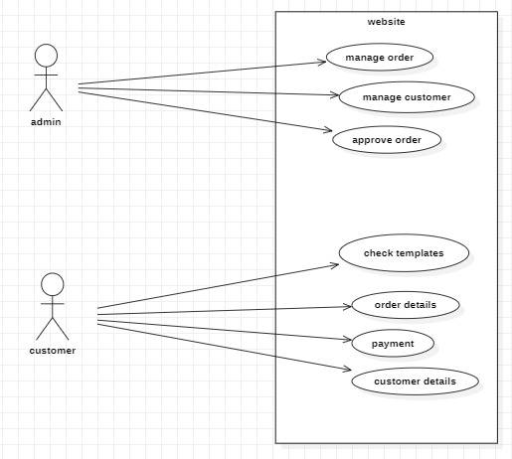

1. Collaboration diagram (For any one-use case)

